Full Stack Development with MERN

1. Introduction
- Project Title: Stock Trading App
- Team Members: Anusha Vemu (Team Lead), Poojitha Kondapalli (Team Member), Sunitha Ganta (Team Member), Padma Priya Anisetti (Team Member), Pooja Sri Kurru (Team Member).
- Introducing the Stock Trading Simulator App – your gateway to a world of financial markets! Whether you're an aspiring investor, a casual browser, or someone on the hunt for the perfect strategy, our app is designed to cater to all your trading needs. With a vast collection of stocks spanning sectors, indices, and market caps, finding your next great investment has never been easier. Explore statistics, read performance logs, and effortlessly purchase or sell virtual equities at your convenience. Dive into the immersive world of finance with the Stock Trading Simulator App – where every virtual trade turns into an investment adventure!
2. Project Overview
- Purpose: The Stock Trading Simulator Application is developed to provide a modern, secure, and user-friendly online platform for buying and managing virtual assets. The project aims to simplify the process of discovering, browsing, and tracking stocks by offering a wide collection of tickers across various industries, indices, and market caps. Built using the MERN Stack (MongoDB, Express.js, React.js, and Node.js), the application enables users to register securely, search for stocks, manage their portfolio watchlist, execute trades, and view their transaction history. It also provides dedicated dashboards for traders and administrators to manage stock listings, balance sheets, users, and transactions efficiently, ensuring a seamless experience for all stakeholders.
- Features: The Stock Trading Simulator Application provides the following key features:
User Registration and Authentication: Secure account registration, login, and user authentication.
Stock Listings: Browse a comprehensive collection of stocks with details such as ticker, company name, sector, price, day change, and market availability.
Advanced Stock Search and Filtering: Search and filter stocks by ticker, company name, industry sector, price range, and percentage changes.
Stock Selection and Watchlist: Add stocks to the watchlist, update target price fields, and manage selected trackings.
Secure Purchase Process: Complete stock purchases securely with automatic transaction generation and portfolio balance updates.
Order Confirmation: Receive order confirmation with transaction ID, purchased stock details, and total asset amount.
Transaction History: View current and previous transactions, track order execution status, and review purchased equities.
Trader Dashboard: Add, update, delete, and manage stock watchlists, balance sheets, and equity orders.
Admin Dashboard: Manage users, traders, stocks, portfolios, orders, and overall platform operations.
Portfolio Management: Monitor capital availability and maintain accurate asset allocation records.
Reporting and Analytics: Generate reports on stock trading volumes, popular sectors, user activity, and platform performance.
Responsive User Interface: Provides an intuitive and consistent experience across desktop, tablet, and mobile devices.
RESTful API Integration: Efficient communication between the frontend, backend, and MongoDB database.
Scalable MERN Architecture: Built using MongoDB, Express.js, React.js, and Node.js for high performance and scalability.
Future Enhancements: Integration with real-time financial market APIs, advanced data charting services, and machine learning stock recommendation engines to enhance functionality and user experience.
3. Architecture
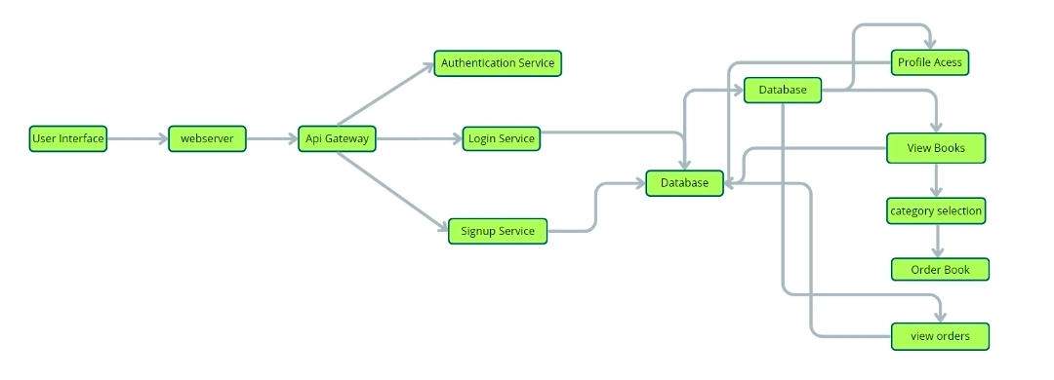
- Frontend: The frontend is built using React.js with a component-based architecture. It uses React Router DOM for navigation, Axios for API communication, and Tailwind CSS/React-Bootstrap for responsive UI. Users can browse stocks, manage their watchlist, execute market orders, and access dashboards through an intuitive interface.
- Backend: The backend is developed using Node.js and Express.js, following a RESTful API architecture. It handles user authentication, stock asset tracking, portfolio configurations, order matchings, and admin operations. Middleware such as CORS, JWT, and Express ensures secure request handling and API communication.
- Database: MongoDB is used to store application data, with Mongoose managing schemas and database operations. The main collections include Users, Stocks, Portfolios, Transactions, Watchlists, and Historical Logs, supporting efficient CRUD operations.
4.Er Diagram
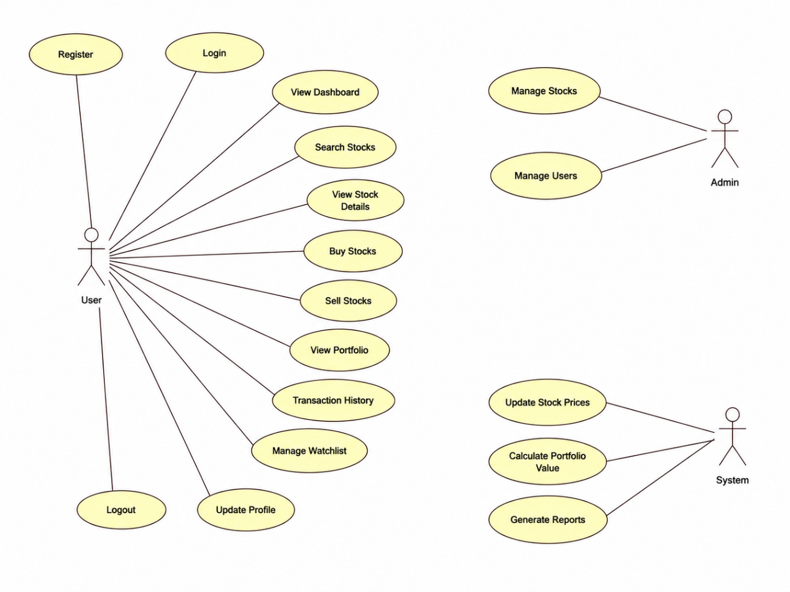
5. Setup Instructions
- Prerequisites: Before setting up the project, install the following software and tools:
Software Requirements
- Node.js (Latest LTS Version)
- npm (Node Package Manager)
- MongoDB Community Edition or MongoDB Atlas
- Git
- Visual Studio Code (or any preferred IDE)
Frontend Dependencies
- React.js
- React Router DOM
- Axios
- Redux Toolkit
- Tailwind CSS
- React Icons
- Chart.js / Recharts
- React Toastify
Backend Dependencies
- Express.js
- MongoDB (Mongoose)
- CORS
- dotenv
- JSON Web Token (JWT)
- bcryptjs
- Morgan
- Nodemon
- Express Validator
Installation:
Step 1: Clone the Repository
git clone https://github.com/your-username/stock-trading-simulator.git
Step 2: Navigate to the Project Directory
cd stock-trading-simulator
Step 3: Install Frontend Dependencies
cd client
npm install
Step 4: Install Backend Dependencies
cd ../server
npm install
Step 5: Create Environment Variables
Inside the server folder, create a .env file and configure the following variables:
PORT=5000
MONGO_URI=your_mongodb_connection_string
JWT_SECRET=your_secret_key
JWT_EXPIRE=7d
CLIENT_URL=http://localhost:5173
Step 6: Start MongoDB
Ensure MongoDB is running locally or connect to your MongoDB Atlas database.
6. Folder Structure
- Client:
client/
│
├── public/
│
├── src/
│ ├── assets/
│ ├── components/
│ ├── pages/
│ ├── layouts/
│ ├── services/
│ ├── context/
│ ├── hooks/
│ ├── routes/
│ ├── App.js
│ ├── main.jsx
│ └── index.css
│
├── package.json
└── vite.config.js

Description
- assets/ – Stores images, logos, icons, CSS files, and other static resources.
- components/ – Contains reusable UI components such as Navbar, Footer, Sidebar, Stock Card, Portfolio Card, and Charts.
- pages/ – Includes application pages such as Home, Login, Register, Dashboard, Market, Portfolio, Watchlist, Transaction History, and Admin Dashboard.
- layouts/ – Defines common layouts shared across different pages.
- redux/ – Manages application state using Redux Toolkit.
- services/ – Contains Axios configuration and API service functions.
- context/ – React Context API for global state management.
- hooks/ – Custom React hooks used throughout the application.
- routes/ – Defines application routing and protected routes.
- utils/ – Utility functions and helper methods.
- App.jsx – Main application component.
- main.jsx – Entry point of the React application.
- index.css – Global CSS styles.
Server:
server/
│
├── config/
├── controllers/
├── middleware/
├── models/
├── routes/
├── services/
├── utils/
├── seed/
├── uploads/
├── .env
├── server.js
├── package.json
└── README.md
Description
- config/ – Database configuration and environment settings.
- controllers/ – Contains business logic for handling API requests.
- middleware/ – Includes authentication, authorization, JWT verification, and error handling middleware.
- models/ – MongoDB schemas for Users, Stocks, Transactions, Portfolios, and Watchlists.
- routes/ – Defines REST API endpoints.
- services/ – Implements business services such as stock price calculations and portfolio management.
- utils/ – Utility functions, helper methods, and reusable logic.
- seed/ – Seed scripts used to populate the database with sample stock data.
- uploads/ – Stores uploaded files or profile images (if applicable).
- .env – Environment variables for database connection, JWT secret, and server configuration.
- server.js – Main entry point of the Express.js backend server.
- package.json – Contains backend dependencies and project scripts.

8. Running the Application
Backend: Start the Backend Server
Step 1: Navigate to the server directory:
cd server
Step 2: Install dependencies (if not already installed):
npm install
Step 3: Start the backend server:
npm run dev
Step 4: The backend server will run on:
http://localhost:5000
Frontend: Start the Frontend Server
Step 1: Navigate to the client directory:
cd client
Step 2: Install dependencies:
npm install
Step 3: Start the React application:
npm run dev
Step 4: The frontend application will run on:
http://localhost:5173

9. API Documentation
Method | Endpoint | Description
POST | /api/auth/register | Register User
POST | /api/auth/login | Login User
GET | /api/auth/profile | Get User Profile
GET | /api/stocks | Get All Stocks
GET | /api/stocks/:id | Get Stock Details
POST | /api/trade/buy | Buy Stock
POST | /api/trade/sell | Sell Stock
GET | /api/portfolio | View Portfolio
GET | /api/transactions | Get Transaction History
GET | /api/watchlist | View Watchlist
POST | /api/watchlist | Add Stock to Watchlist
DELETE | /api/watchlist/:id | Remove Stock from Watchlist
GET | /api/admin/users | Get All Users
POST | /api/admin/stocks | Add New Stock
PUT | /api/admin/stocks/:id | Update Stock
DELETE | /api/admin/stocks/:id | Delete Stock

Example Response
{
"success": true,
"message": "Stock purchased successfully",
"data": {
"stockName": "TCS",
"quantity": 10,
"price": 3650,
"totalAmount": 36500
}
}

10. Authentication
- Users register and log in using their email address and password.
- Passwords are securely hashed using bcryptjs before being stored in the database.
- Authentication is implemented using JWT (JSON Web Token).
- Protected API routes require a valid JWT token in the Authorization header.
- Role-based authorization is used to restrict access to administrative features.
User Permissions
➤ Register and Login
➤ View Available Stocks
➤ Buy Stocks
➤ Sell Stocks
➤ View Portfolio
➤ Manage Watchlist
➤ View Transaction History
➤ Update Profile
Administrator Permissions
➤ Manage Users
➤ Add New Stocks
➤ Update Stock Information
➤ Delete Stocks
➤ View System Reports
➤ Monitor User Activities
➤ Logout securely destroys the current user session.

11. Testing
- Backend: Test REST APIs, authentication, authorization, CRUD operations, and error handling.
- Frontend: Test UI components, navigation, forms, dashboards, and trading functionality.
- Integration: Verify communication between React, Express.js, and MongoDB.
- Tools: Postman, Jest, MongoDB Compass, Chrome Developer Tools, React Developer Tools.
- Functional Testing: Verify registration, login, stock buying, stock selling, portfolio updates, and watchlist operations.

12. Future Enhancements
- Integrate live stock market APIs (Yahoo Finance, Alpha Vantage, etc.).
- Implement AI-based stock price prediction.
- Add real-time stock price updates using WebSockets.
- Enable email notifications for trade confirmations.
- Introduce two-factor authentication (2FA).
- Develop Android and iOS mobile applications.
- Add portfolio analytics and performance charts.
- Support multiple currencies and international stock exchanges.
- Deploy the application using Docker and cloud platforms (AWS, Azure, or Render).
- Implement dark mode, multilingual support, and advanced search filters.

13.Project Structure
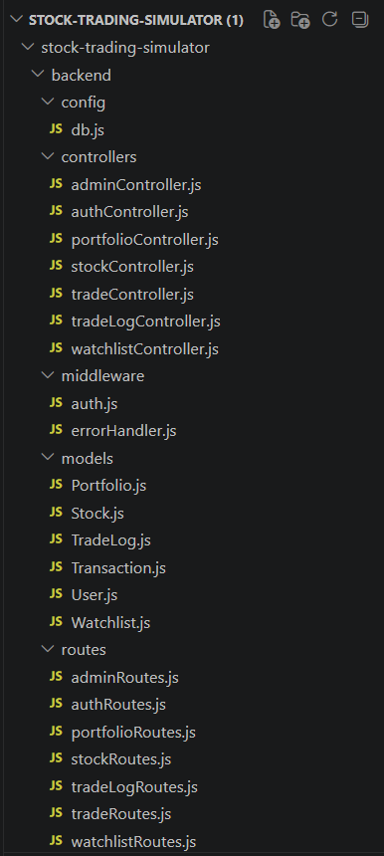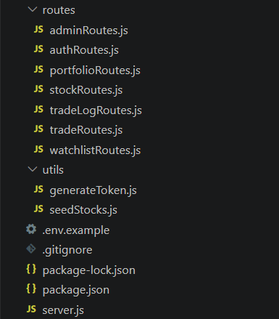
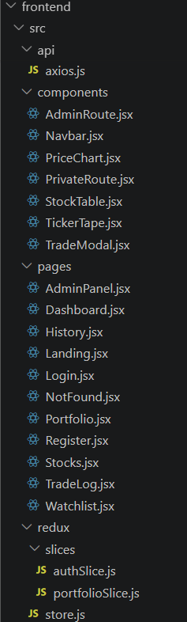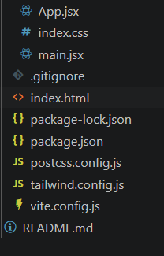
- The first image is of frontend part which is showing all the files and folders that have been used in UI development
- The second image is of Backend part which is showing all the files and folders that have been used in backend development

14. Project Flow
Before starting to work on this project, let's understand the overall workflow of the Stock Trading Simulator application.
Project Demo:
https://drive.google.com/file/d/1WLxZr-ndW7gKbmwB7DGCQ34F64gXaFOE/view?usp=drive_link
GitHub Repository:
https://github.com/vemuanusha/Stock-Trading-App-Smart-Bridge
Milestone 1: Project Setup and Configuration
• Folder Setup
- Create the client folder.
- Create the server folder.
- Configure the project directory structure.
- Connect GitHub repository.

• Installation of Required Tools
1. Open the Client folder and install required libraries.
2. Frontend Technologies Used
- React.js
- Vite
- React Router DOM
- Axios
- Redux Toolkit
- Tailwind CSS
- React Icons
- Chart.js / Recharts
- React Toastify
- ESLint

3. Open the Server folder and install required libraries.
4. Backend Technologies Used
- Node.js
- Express.js
- MongoDB
- Mongoose
- JWT (JSON Web Token)
- bcryptjs
- dotenv
- cors
- Morgan
- Nodemon
- Express Validator
After the installation of all the libraries, the package.json files for the frontend looks like the one mentioned below.

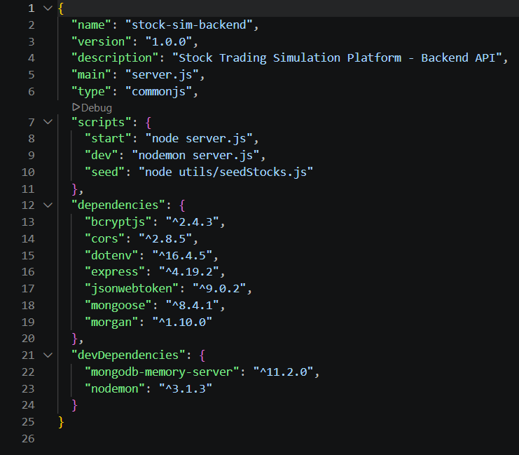
- After the installation of all the libraries, the package.json files for the backend looks like the one mentioned below.
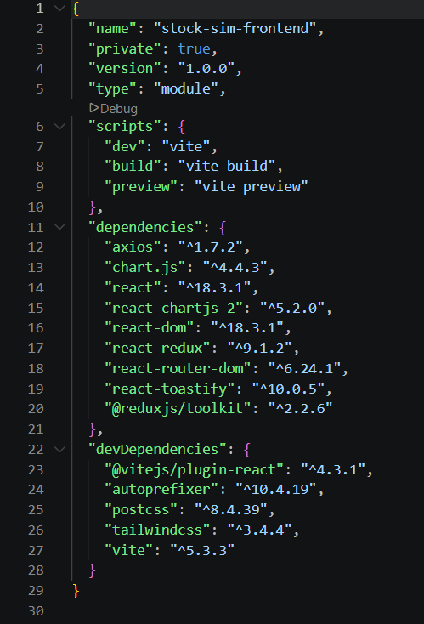
Milestone 2: Backend Development
• Setup Express Server
- Create server.js file in the server (backend) folder.
- Define the port number, MongoDB connection string and JWT secret key in the .env file.
- Configure the server by adding Express, CORS, and dotenv.

• Configure MongoDB
- Import Mongoose.
- Add database connection in config/db.js.
- Create models for User, Stock, Portfolio, and Transaction.
• Add Authentication
For this,
Create a middleware folder and inside it create authMiddleware.js for user authentication using JWT and use it to protect the required routes.
Milestone 3: Database Development
➤ Set up a MongoDB database either locally or using MongoDB Atlas.
➤ Create the required collections for Users, Stocks, Portfolio, and Transactions.
➤ Also see the detailed description of the database schemas used in the project.
➤ For connecting the database, use the code available in config/db.js.

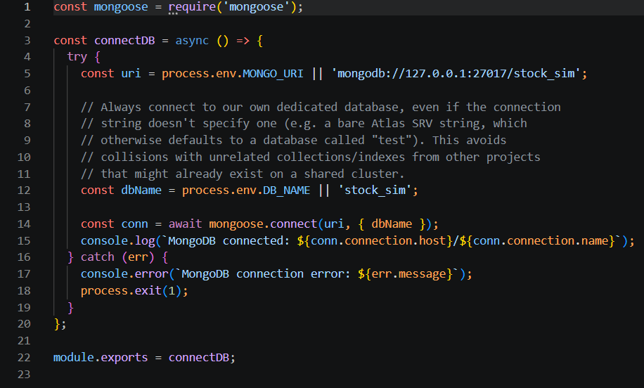

Milestone 4: Frontend Development
1. Setup React Application
The Stock Trading Simulator frontend was developed using React.js to provide a fast, responsive, and user-friendly interface. The development process began by setting up the React application, installing the required dependencies, and organizing the project structure for efficient development.
The following activities were performed:
- Created the React application.
- Installed the required libraries (React Router DOM, Axios, Redux Toolkit, Tailwind CSS, React Icons).
- Created the project folder structure.
- Configured routing for navigation between pages.
- Organized reusable components, pages, assets, and utility files.
2. Design UI Components
The user interface was designed using reusable React components to provide a simple and user-friendly experience.
The following components were developed:
- Navigation Bar
- Home Page
- Dashboard
- Stock List
- Stock Details Page
- Buy Stock Page
- Sell Stock Page
- Portfolio Page
- Transaction History
- Watchlist
- User Login and Registration
- User Profile
- Admin Dashboard
- Footer
- Search Bar
Responsive layouts and consistent styling were implemented using Tailwind CSS to ensure compatibility across different screen sizes.
3. Implement Frontend Logic
The frontend logic connects the user interface with the backend services and manages application data efficiently.
The implementation includes:
- Integration with backend REST APIs.
- User authentication.
- Fetching and displaying stock data from the database.
- Stock search and filtering.
- Buying and selling stocks.
- Portfolio management.
- Transaction history.
- Watchlist management.
- State management using Redux Toolkit.
- Dynamic rendering of stock information.
4. Database Schema
The Stock Trading Simulator application uses MongoDB as the database and Mongoose as the Object Data Modeling (ODM) library. Mongoose schemas define the structure of the data stored in each collection.
1. User Schema
The User schema stores user and administrator information.
It contains the following details:
- User Name
- Email Address
- Password (Encrypted)
- Role (User/Admin)
- Available Balance
- Portfolio Value
- Created Date
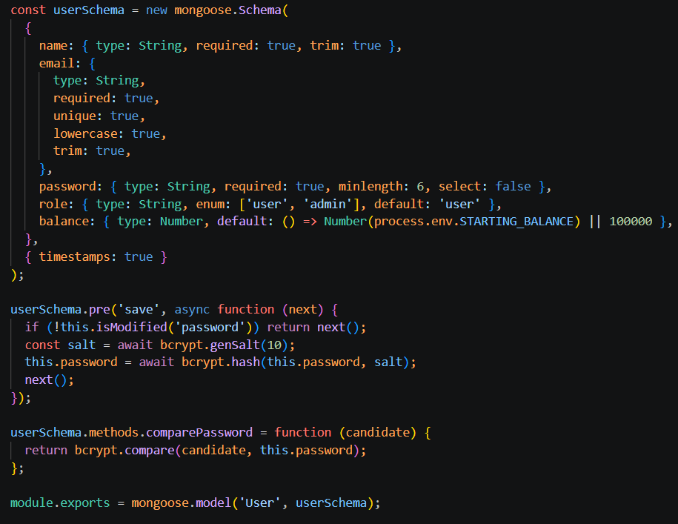
2. Stock Schema
The Stock schema stores the information of all available stocks.
It contains the following details:
- Stock Name
- Stock Symbol
- Company Name
- Current Price
- Market Price
- Available Quantity
- Category
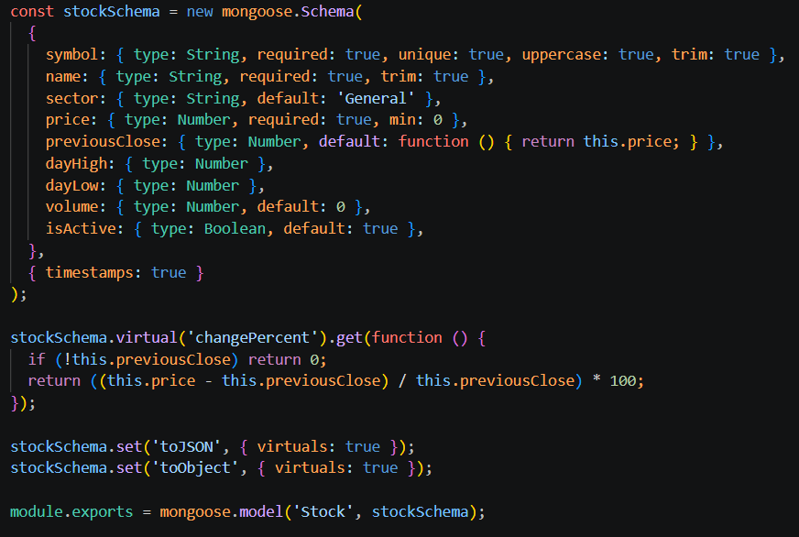
3. Portfolio Schema
The Portfolio schema stores the stocks purchased by each user.
It contains the following details:
- User ID
- Stock ID
- Quantity Purchased
- Purchase Price
- Total Investment
- Current Value
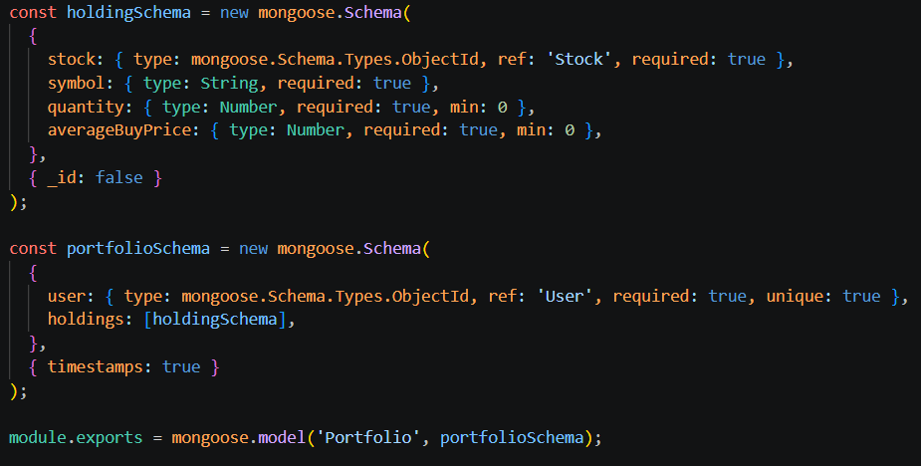
4. Transaction Schema
The Transaction schema stores all stock buying and selling records.
It contains the following details:
- User ID
- Stock ID
- Transaction Type (Buy/Sell)
- Quantity
- Price
- Total Amount
- Transaction Date
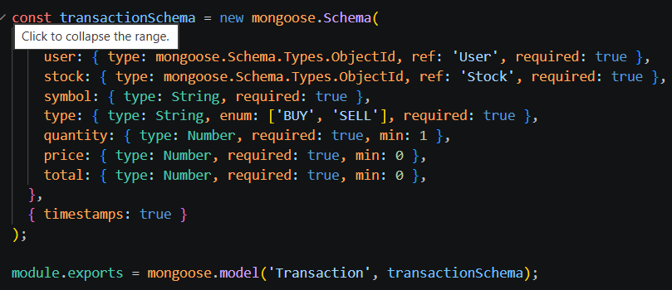

5. Watchlist Schema
The Watchlist schema stores the list of stocks saved by users for future tracking.
It contains the following details:
- User ID
- Stock ID
- Added Date

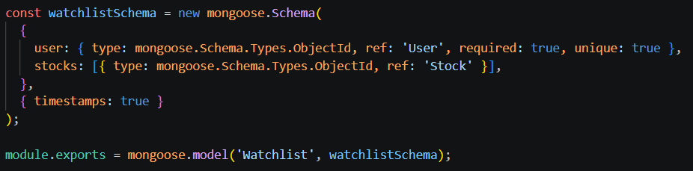
15. Project Implementation
• User Registration (Sign Up)
The User Registration module allows new users to create an account by entering their name, email address, and password. The application validates the entered information before sending it to the backend. After successful registration, the user's details are securely stored in the MongoDB database, and the user can log in to access the application's features.
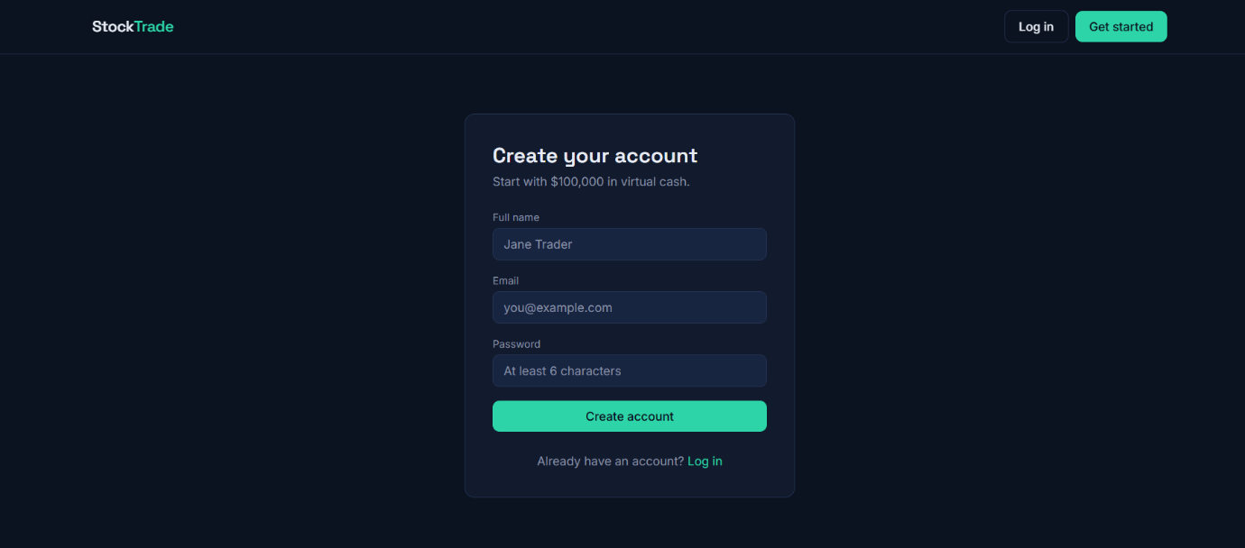

• User Login:
The Login module authenticates registered users using their email address and password. After successful authentication, users can securely access their dashboard and use the stock trading features.


• Dashboard
The Dashboard displays all the available stocks in an organized layout. Users can browse different stocks, view stock symbols, company names, prices, and market details.

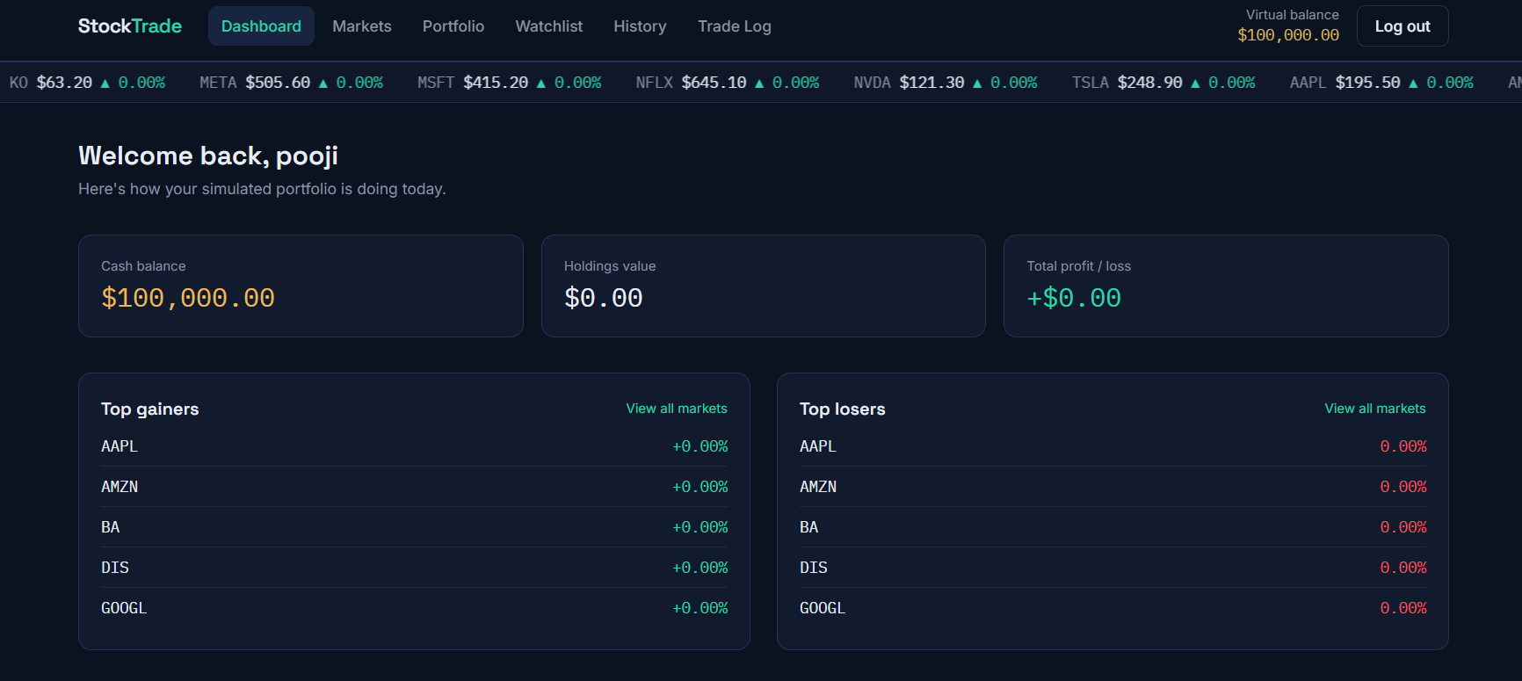

• Markets
The Markets page displays the list of available stocks with their current market prices and percentage changes. Users can browse stocks and select any stock for trading.
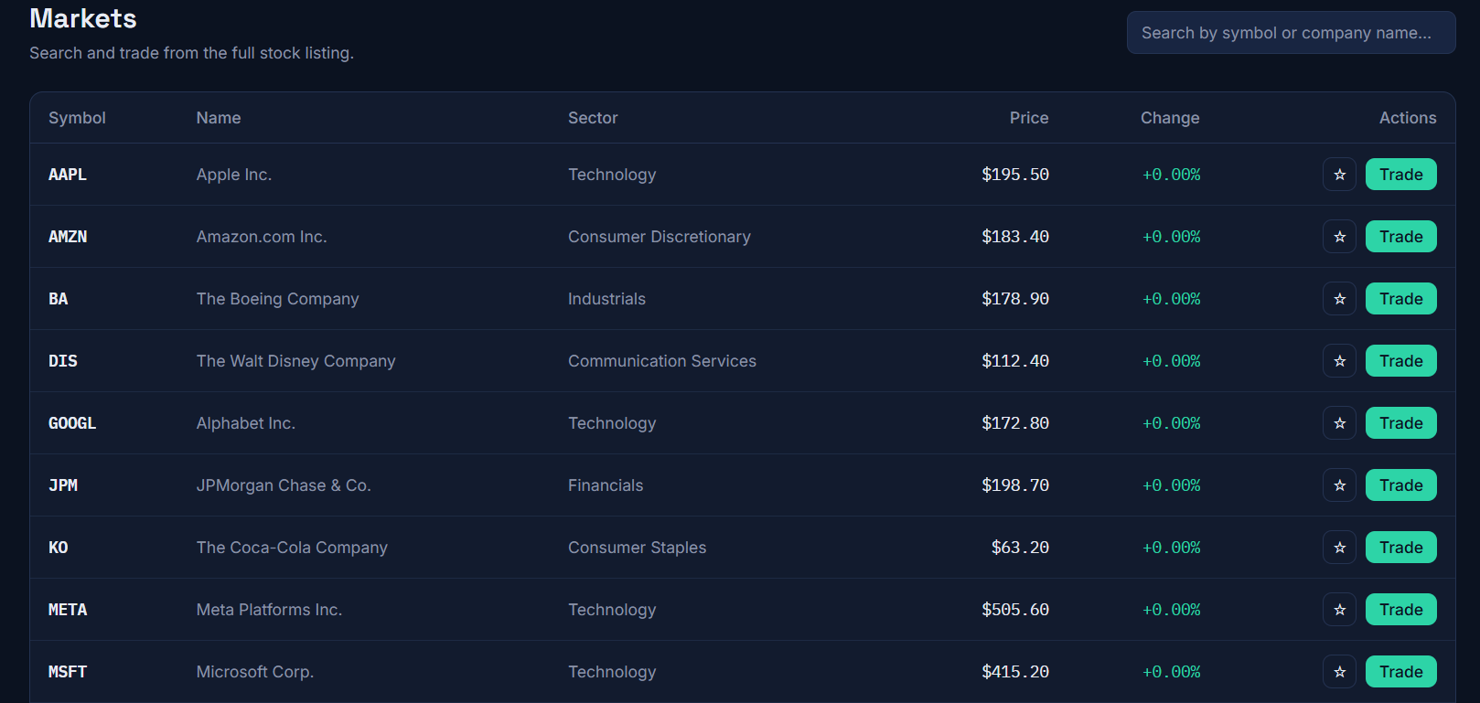

• Portfolio
The Portfolio page displays all the stocks purchased by the user. It shows the quantity owned, purchase value, current market value, and profit or loss for each stock.
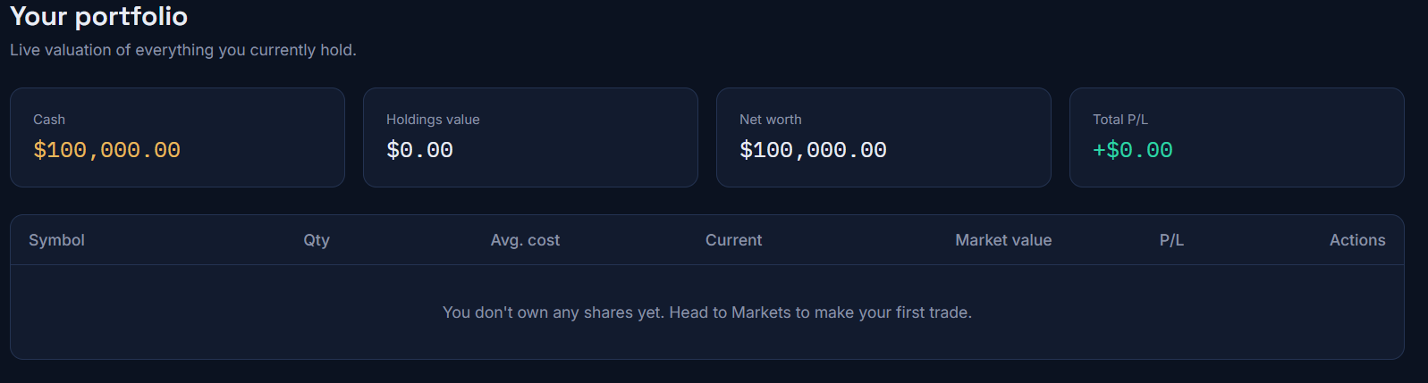

• Watchlist
The Watchlist page allows users to save their preferred stocks for future tracking. Users can monitor stock performance without purchasing them.
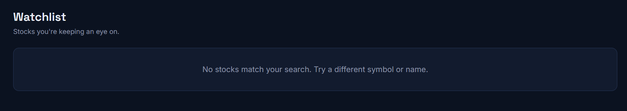

• History
The History page displays all completed trading transactions. It contains details such as stock name, transaction type (Buy/Sell), quantity, price, and transaction date.
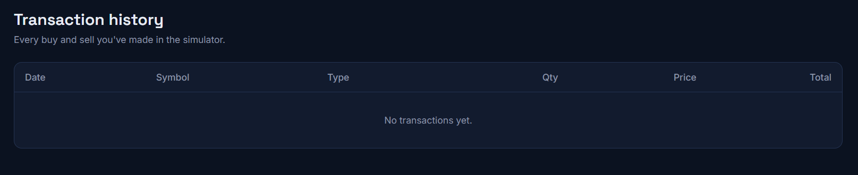

• Trade Log
The Trade Log page maintains a complete log of all trading activities performed by the user. It provides a detailed record of buy and sell operations for future reference.
